

stock prediction using machine learning



Author

D.vamsi krishnam raju

HU21CSEN0300142

B.tech CSE(AIML)

GITAM SCHOOL OF TECHNOLOGY HYD

Acknowledgment

I want to acknowledge Google for providing a collab notebook to run GPU-based programs without having an original GPU with us. It has a built-in cloud virtual machine that runs Linux operating system on a cloud for free without any premium.

I want to thank Kaggle for providing the dataset for this stock prediction.

Content:

1.Introduction

2.What is stock market

3. Ai role in stock market

4.Lstm(long short term memory)

5.Stock prediction model

*Raw data

*Data preprocessing

*Feature Extraction

*Training neural networks

*Output generation

*Visualization

6.Conclusion

7.Resources

Introduction

Stock market prediction is the act of trying to determine the future value of a company stock or other financial instrument traded on a exchange. The successful prediction of a stock’s future price could yield significant profit.

The Ai came the into picture to predict the stock. We will write some ai algorithms and we create RNN networks and LSTM to predict the stock . This ai is mainly recommended to stock marketers ,and their work completes easier because of predictions which are given by Ai.

What is stock market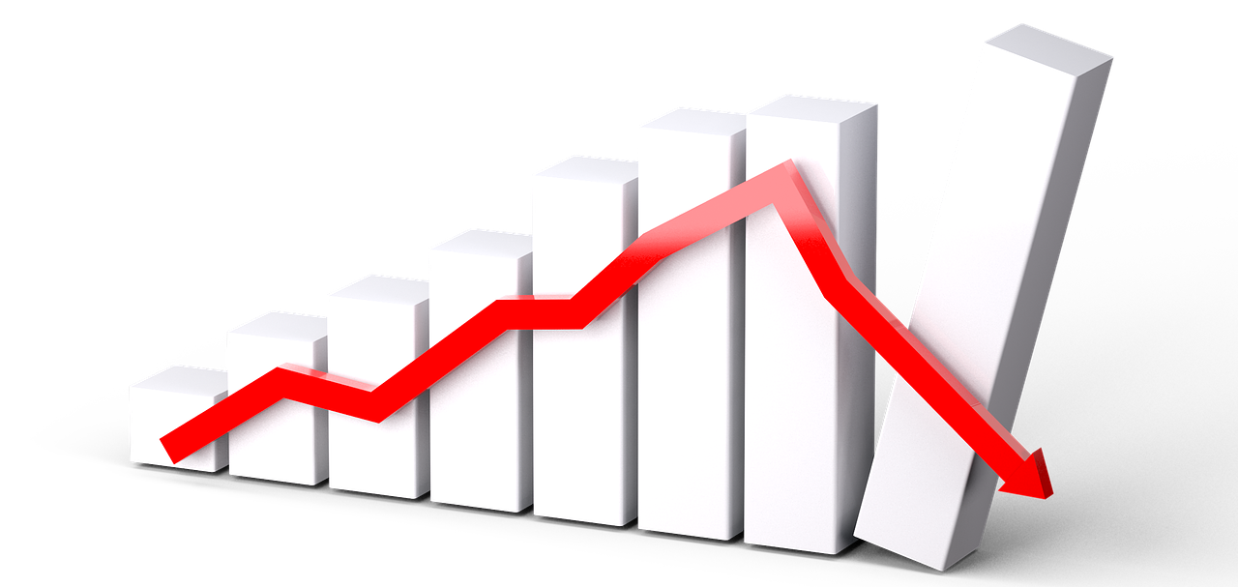

A **stock market**, **equity market**, or **share market** is the aggregation of buyers and sellers of [stocks](https://en.wikipedia.org/wiki/Stock) (also called shares), which represent [ownership](https://en.wikipedia.org/wiki/Ownership) claims on businesses; these may include *securities* listed on a public [stock exchange](https://en.wikipedia.org/wiki/Stock_exchange), as well as stock that is only traded privately, such as shares of private companies which are sold to [investors](https://en.wikipedia.org/wiki/Investor) through [equity crowdfunding](https://en.wikipedia.org/wiki/Equity_crowdfunding) platforms. Investment in the stock market is most often done via [stockbrokerages](https://en.wikipedia.org/wiki/Stockbroker) and [electronic trading platforms](https://en.wikipedia.org/wiki/Electronic_trading_platform). Investment is usually made with an [investment strategy](https://en.wikipedia.org/wiki/Investment_strategy) in mind. A stock is a financial instrument that represents ownership in a company or corporation and represents a proportionate claim on its assets (what it owns) and earnings (what it generates in profits). Stocks are also called shares or a company's equity[[1]](https://en.wikipedia.org/wiki/Stock_market#cite_note-1).

Stocks can be categorized by the country where the company is domiciled. For example, [Nestlé](https://en.wikipedia.org/wiki/Nestl%C3%A9) and [Novartis](https://en.wikipedia.org/wiki/Novartis) are domiciled in [Switzerland](https://en.wikipedia.org/wiki/Switzerland) and traded on the [SIX Swiss Exchange](https://en.wikipedia.org/wiki/SIX_Swiss_Exchange), so they may be considered as part of the [Swiss](https://en.wikipedia.org/wiki/Switzerland) stock market, although the stocks may also be traded on exchanges in other countries, for example, as [American depositary receipts](https://en.wikipedia.org/wiki/American_depositary_receipt) (ADRs) on U.S. stock markets.

Ai role in stock market

**Trading and investment**

[Algorithmic trading](https://en.wikipedia.org/wiki/Algorithmic_trading) involves the use of complex AI systems to make trading decisions at speeds several orders of magnitudes greater than any human is capable of, often making millions of trades in a day without any human intervention. Such trading is called [High-frequency Trading](https://en.wikipedia.org/wiki/High-frequency_Trading), and it represents one of the fastest-growing sectors in financial trading. Many banks, funds, and proprietary trading firms now have entire portfolios that are managed purely by AI systems. [Automated trading systems](https://en.wikipedia.org/wiki/Automated_trading_system) are typically used by large institutional investors, but recent years have also seen an influx of smaller, proprietary firms trading with their own AI systems.[[64]](https://en.wikipedia.org/wiki/Applications_of_artificial_intelligence#cite_note-64)

Several large financial institutions have invested in AI engines to assist with their investment practices. [BlackRock](https://en.wikipedia.org/wiki/BlackRock)’s AI engine, [Aladdin](https://en.wikipedia.org/wiki/Aladdin_(BlackRock)), is used both within the company and to clients to help with investment decisions. Its wide range of functionalities includes the use of natural language processing to read text such as news, broker reports, and social media feeds. It then gauges the sentiment on the companies mentioned and assigns a score. Banks such as UBS and Deutsche Bank use an AI engine called Sqreem (Sequential Quantum Reduction and Extraction Model) which can mine data to develop consumer profiles and match them with the wealth management products they’d most likely want.

Lstm(long short term memory)

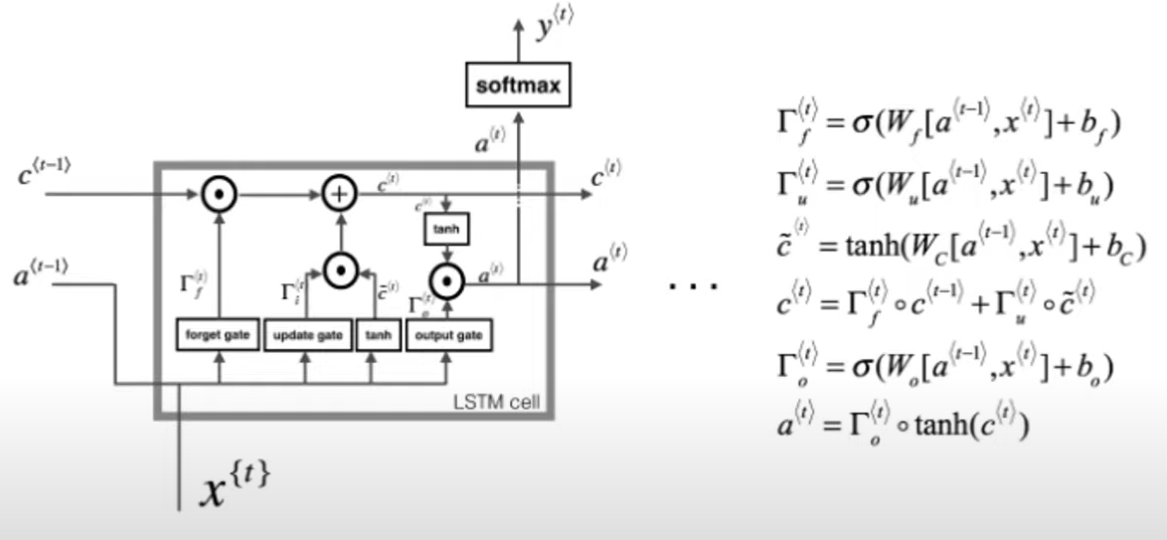

LSTMs are a variation of the RNN architecture.

The memory cells in the lstm will make networks to run effectively associate memories and input remote in time hence,suit to grasp the structure of data dynamically over time with the high prediction capacity. We will be using forecasting technology to predict the stock.

Stock Prediction Model

1.Raw data

The historical stock data is collected from the google stock price and this historical data is used for the prediction of the future stock prices.

2.Data Preprocessing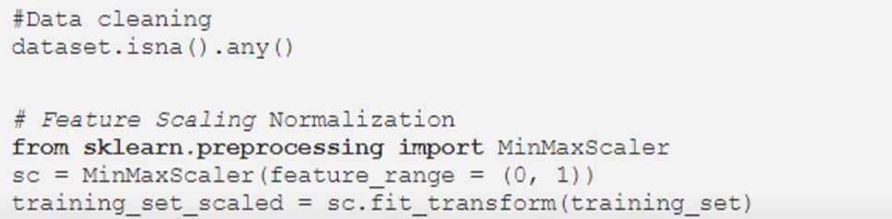

The pre-processing stage involves Data discretization, Data transformation, Data cleaning, Data integration. After the Dataset is transformed into a clean dataset, the dataset is divided into training and testing sets to evaluate.

3.Feature Extraction

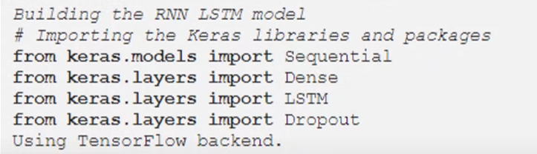

In this layer only the features which are to be fed to the neural networks are choosed.

4.Training neural network

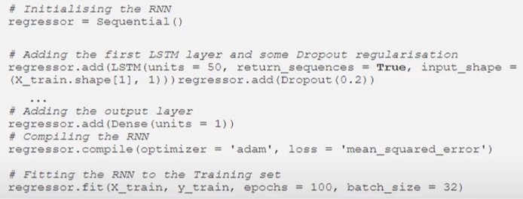

In this stage ,the data is fed to the neural network and trained for prediction assigning random biases and weights.

4.1 Optimizer

The type of optimizer used can greatly affect how fast the algorithm converges to the minimum value. Here we here chosen to use Adam optimizer. The Adam optimizer combines the perks of two other optimizers;

ADAgrad and RMSprop.

4.2 Regularization

Another important aspect of train the model is making sure the weight do not get too large, hence, overfit. For this purpose , we have chosen to use tikhnov-regularization.

4.3 Dropouts

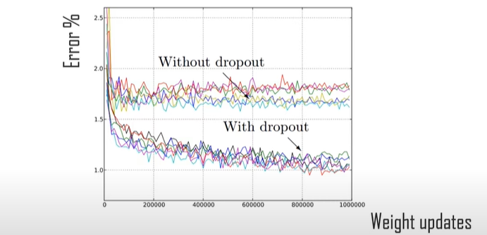

Dropouts are used in making the neurons more robust and hence allowing them to predict the trend with focusing any one neuron.

5.Output Generation

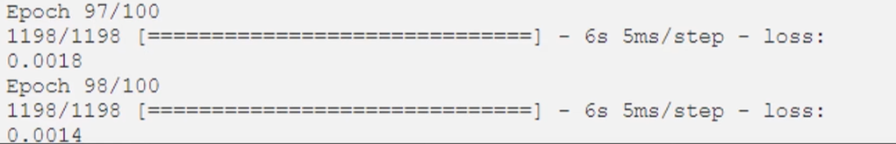

In this layer, the output value generated by the output layer of the RNN is compared with the target value. The error or the difference between the target and the obtained output value is minimized by using back propagation algorithm.

6.Visualization

A rolling analysis of a time series model is often used to access the model’s stability over time. When analyzing financial time series data using a statistical model, a key assumption is that the parameters of the model are constant overtime .

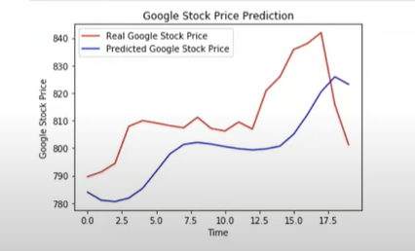

Conclusion

The fore-casting technology is used to represent the real time stock price prediction . Thanks to the RNN which has generated such an amazing model output for predicting the stock price.

Resources

What is stock market- Wikipedia

Ai role in stock market- Wikipedia

Images- versatiledvkr pc